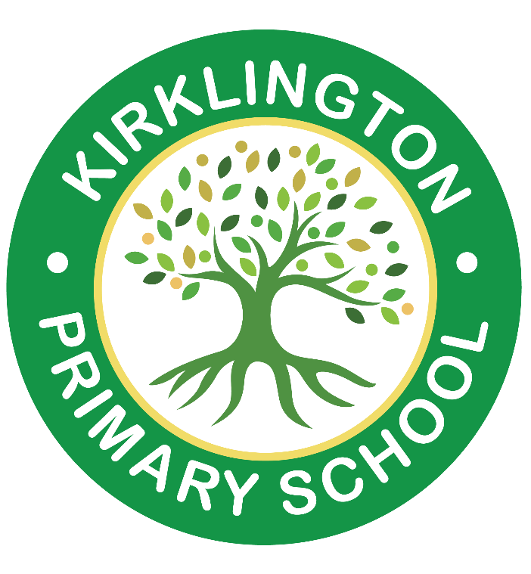
Kirklington Primary School
School Address: School Lane, Kirklington, Newark, NG22 8NG
Tel: 01636 551122
Email: office@kirklington.notts.sch.uk

Head Teacher: Mrs Tracy Burn-Smith/Mrs Louisa Williams

Consultation Response Form

Kirklington Primary School 2027-2028 admission arrangements
1. Do you agree with the proposed changes to the 2027-2028 admission arrangements for the school?

Yes

No

2. Do you have any comments you would like to make about the proposed admission arrangements for the school?

Please return your completed response form to the school office, before the consultation closing date.
Period of Consultation is from 22nd December 2025 – 31s January 2026

